FACILITATOR MESSAGES/EMAILS
FOR THE ONLINE MONEYLIFE COURSE

Dear MoneyLife Facilitator,
Thank you for your willingness to lead an online MoneyLife group! May God honor your desire to help others discover the power of Redemptive Stewardship, encouraging them to manage and multiply all of God’s resources for His glory. We’re confident the Lord will transform hearts and lives if participants faithfully apply the biblical stewardship principles in this course.
As a Facilitator, it’s essential for you to connect with group members regularly throughout the course. You can do this using the Messages function, which is available in the Discussions section of the online course (shown below).
You can also post thought-provoking questions in the Discussions section, which will motivate group members to share what God is teaching them.

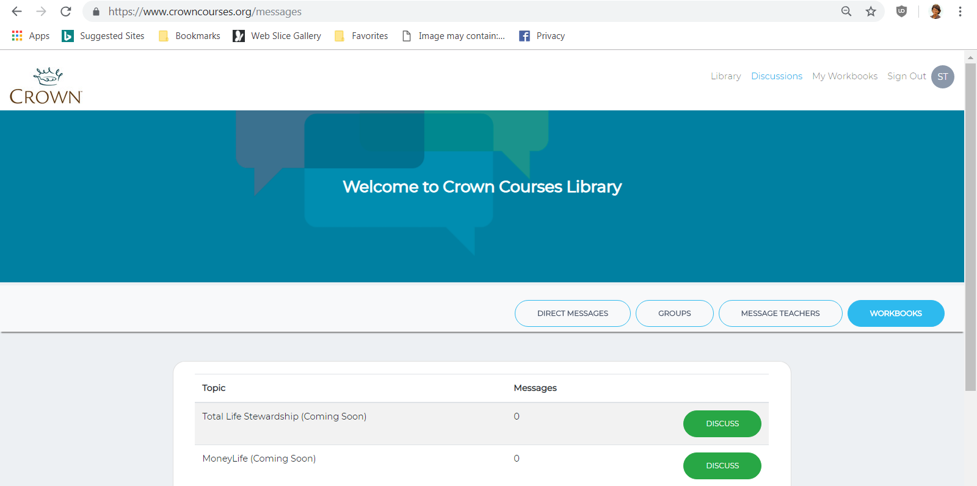
Another option is to send weekly emails to your group using Gmail, Outlook, Apple Mail, etc. The communication method is based on your personal preference. The important part is to stay connected with participants throughout the course. This document includes suggested verbiage about each lesson that you can use when communicating with your group. Feel free to change the content to reflect your own style, as well as the specific lessons your group will study.
May God abundantly bless you and your group members, as you seek Him throughout the MoneyLife course!
Sincerely,
Your Crown Team
LESSON 1 - UNWAVERING HOPE
The first lesson in the MoneyLife course begins with a foundational topic -- Unwavering Hope. Some of us may have been placing our hope in the world’s wisdom, only to find it doesn’t work. In this study, we’ll learn to rely on timeless biblical principles that can transform both our beliefs and behaviors.
Here are a few practical tips to help you get started. First, you’ll need to access the online course:

- Click HERE (or type https://crownonline.org/ into your browser address bar).
- Review the information on the page to get familiar with the platform.
- Click the Get Started button at the top or bottom of the page
- Scroll down to view the courses available in the library
- Find the MoneyLife “library card,” which should be first in the list
- Click Details to learn about the course, or click the price button to access the course
- Log in
  - If you don’t have a CrownOnline account yet, you will be prompted to create one. Enter your name, email address, a password of your choosing, and your phone number (optional). Then click Next.
  - Enter your billing details for the course fee.
  - If you already have a CrownOnline account, scroll to the bottom of the account page and click Sign In. Ener your email address and password, then click Sign In.
- After completing the payment process, you’ll have immediate access to the course content.
Once you’re in the MoneyLife course:
- Click on A Word of Introduction in the left navigation panel, watch the video, and read the introductory notes.
- Then click on How this Course Works for important information about navigating the online study.
  - After completing How this Course Works, click Continue and Save (in the top right menu) to move to the next section.
  - The section headers (such as Introduction, Lesson 1, Lesson 2) in the left navigation panel are for formatting purposes only.
  - After completing the Homework for a lesson, click Continue and Save twice to move past the section header to the Overview & Notes for the next lesson.
- The easiest way to save your homework answers and notes is to enter them in the online platform. Alternatively, there is a downloadable PDF if you prefer to write out your answers by hand.
- We encourage you to participate in the Discussions for the lesson, so we can all learn from each other.
If you have any questions about our first lesson, please don’t hesitate to contact me. I look forward to seeing what God does in each of our lives as we put His principles into practice!
Sincerely,
[Facilitator Name]
LESSON 2 - THE PLAN
How did you do with the first lesson in the MoneyLife Study? Hopefully you were faithful to complete the scripture memorization, homework, and practical application assignments. No matter how busy your life is, one of the best investments you’ll ever make is the time spent studying God’s principles of stewardship and life!
During this week, we’ll learn about an important step on our journey to financial freedom. As we put God’s principles into action, it’s essential to start with a realistic spending plan. Winston Churchill said, “He who fails to plan is planning to fail.”
Although a budget is often viewed as restrictive, it can actually be very freeing. A plan empowers us to proactively decide where we’ll spend the resources God gives us. Whether we’re struggling with money or things are going well for us, the Bible encourages us to seek God’s direction for our financial plan. Why? Because Knowing + Doing + Trusting = Contentment.
Let’s roll up our sleeves and dive into this week’s lesson! May God help us be “doers” of the Word, as we put His timeless principles into practice!
Sincerely,
[Facilitator Name]

LESSON 3 - DITCHING DEBT
Now that we’re filled with hope and we understand the ingredients of a good financial plan, it’s time to look at an area that can derail our ability to live as faithful stewards.
Have you ever felt like a servant to your lenders? As we study God’s perspective on debt, we’ll see that He cautions us to avoid it. And if we do incur debt, He encourages us to pay it off as quickly as possible. During this lesson, we’ll learn that eliminating debt can be one of the most liberating decisions we’ll ever make.

Deuteronomy 14:2 tells us that the Lord chose Israel to be a peculiar people unto Himself. We’ve been grafted into His family, which enables us to live differently than the rest of our culture. Debt is considered a way of life in many nations, but remember that our real citizenship is in Heaven. Don’t give up. The rewards for persevering on our journey to financial freedom will be well worth it!

Sincerely,

[Facilitator Name]

LESSON 4 - SAVE IT
In last week’s lesson, we read that signing up for “easy financing” is equivalent to selling ourselves as slaves. For those who are struggling with poor financial decisions from the past, don’t despair. God is bigger than your debt!

This week, we’ll learn that saving is a key to ending the debt cycle – as well as the cornerstone of wise stewardship. Perhaps you’ve wondered if it’s biblical for God’s children to save -- or does it mean we don’t trust our Heavenly Father to provide for us? You may be surprised to learn that God’s Word actually instructs us to save.
In this lesson, we’ll examine the biblical principles that encourage us to sacrifice in the short-term to attain long-term goals. With a little discipline, we can be prepared to meet our own needs and the needs of others.

There are numerous scriptures that encourage us to save, but just as many that warn against placing our trust in earthly riches. The key is to remember that our confidence should always be in God. Let’s strive to be wise stewards, so we can “take hold of the life that is truly life” described in I Timothy 6:19.
Sincerely,

[Facilitator Name]

LESSON 5 – INVESTING

Did you learn anything new last week as you studied the biblical principles on saving? Hopefully we all recognize now that saving is an example of God’s grace in action.
In Lesson 5, we’ll look at whether God distinguishes between saving and investing. Many Christians are confused about the concept of investing, and they’re not sure it’s biblically acceptable to store up wealth for the future.
This week, we’ll study the importance of investment principles such as liquidity and diversification. We’ll also examine the dangers of greed and chasing after worldly wealth, rather than eternal rewards. Crown doesn’t provide specific investment advice, but we want to equip you as a wise investor of the resources God entrusts to you.

If the topic of investing isn’t one that normally interests you, you may be tempted to skip this week’s lesson. Please don’t! God’s Word will not return to Him void, and I’m confident the Holy Spirit has something to teach all of us. So let’s dig in together, as we learn what it means to be God’s investment managers!
Sincerely,

[Facilitator Name]

LESSON 6 - GOOD WORK

Were you surprised by the investing principles we studied last week? Although God encourages us to save for planned and unplanned needs, He also wants us to remember that He is ultimately our Provider.

This week, we’ll look at the stewardship of our time and talents. Do you view work as a gift from God -- or a negative consequence of Adam’s fall? In this lesson, we’ll learn that stewardship of our talents is an important responsibility. We’ll review God’s plan to use the skills He gives us for His Kingdom purposes. We’ll also consider the benefits of hard work and the danger of overwork.

May the Lord bring abundant fruit from the time and effort you’re investing in this study!
Sincerely,

[Facilitator Name]

LESSON 7 - GENEROUS LIVING
Last week, we learned that work is one way we express worship to God. When we view work as an opportunity to bring Him glory, we find greater meaning and satisfaction in our jobs. It doesn’t matter what type of role He calls us to – all work is sacred when we do it for Him.

This week, we’ll study the important topic of generosity. To live generously, do we have to give everything away and take a vow of poverty? Is there a connection between generosity and our relationship with Christ? In this lesson, we’ll look at how to give, where to give, and how much to give. By studying God’s Word, we see the temporal and eternal advantages of being generous with our time, talent, and treasure.

Faithfulness and perseverance are essential if we want to achieve true financial freedom. Let’s keep applying what we’re learning in God’s Word and trust that He will reward our obedience!
Sincerely,

[Facilitator Name]

LESSON 8 - PAY IT FORWARD
In our last lesson, we learned that giving isn’t merely another category in our spending plan. Instead, it should be an act of worship. It helps us draw closer to God and is one of the privileges we have as believers. When we give generously of our time, talent, and treasure, we join God in demonstrating His love and kindness to the world.

Next we’ll look at the importance of sharing the principles we’re learning. Are we being intentional about teaching others – especially the next generation -- to handle money from a Biblical perspective? This week, we’ll review age-appropriate lessons that will benefit children, teens, and young adults. We’ll also see that God’s Word encourages us to leave a lasting legacy – one that includes much more than money. Get ready to learn practical steps you can take to help others become faithful with money and possessions.
Kudos for making it this far! Keep pressing on – the finish line is just around the corner. By applying the principles we’re learning from God’s Word, we’ll experience benefits in this life and the next!
Sincerely,

[Facilitator Name]

LESSON 9 - TRULY RICH
Throughout this study, we’ve looked at many important biblical truths about money and possessions. We’ve also learned practical ways to apply the principles God gives us in His Word.
Now it’s time to consider what it means to be “truly rich.” Do you consistently acknowledge God’s ownership of the money and possessions you have? In this lesson, we’ll study what being truly rich looks like in the life of a Christ follower. We’ll also learn what the Lord expects from us as His stewards.

Let’s reflect this week on what our checkbook says about our role as stewards. Are we ordering our finances so we can spend as much as we want on whatever we want? Or have we surrendered everything we have to God, so He can spend us however He wants?
Sincerely,

[Facilitator Name]

LESSON 10 - THE CHOICE
During this course, we’ve studied God’s perspective on a variety of topics -- hope, planning, ditching debt, saving and investing, work, generous living, paying it forward, and what it means to be truly rich. This is the final lesson in our study, and I commend you for making it to the finish line!
This week, we’ll look at simple, daily choices to help us overcome financial challenges and live a life of purpose and meaning. As we wrap up the study, we’ll also consider God’s standard for honesty – including the connection between integrity and our love for Him and our neighbor. At the end of the lesson, we’ll have an opportunity to reflect on the lifestyle changes we’ve made (or will make) as a result of what we’ve learned throughout this study.

As you probably realize, our work isn’t over just because the course has ended. It will take ongoing commitment for each of us to reach our goals. May the biblical principles we’ve learned in this course guide our beliefs and behaviors for the rest of our lives. Remember, every financial decision we make is a spiritual decision!
Sincerely,

[Facilitator Name]

